Skagit Trail Builders
May 23, 2026 Work Party Plan
Norlum Trail, Port of Skagit SWIFT Center
Edited May 22, 2026 - Jenny Sandbo
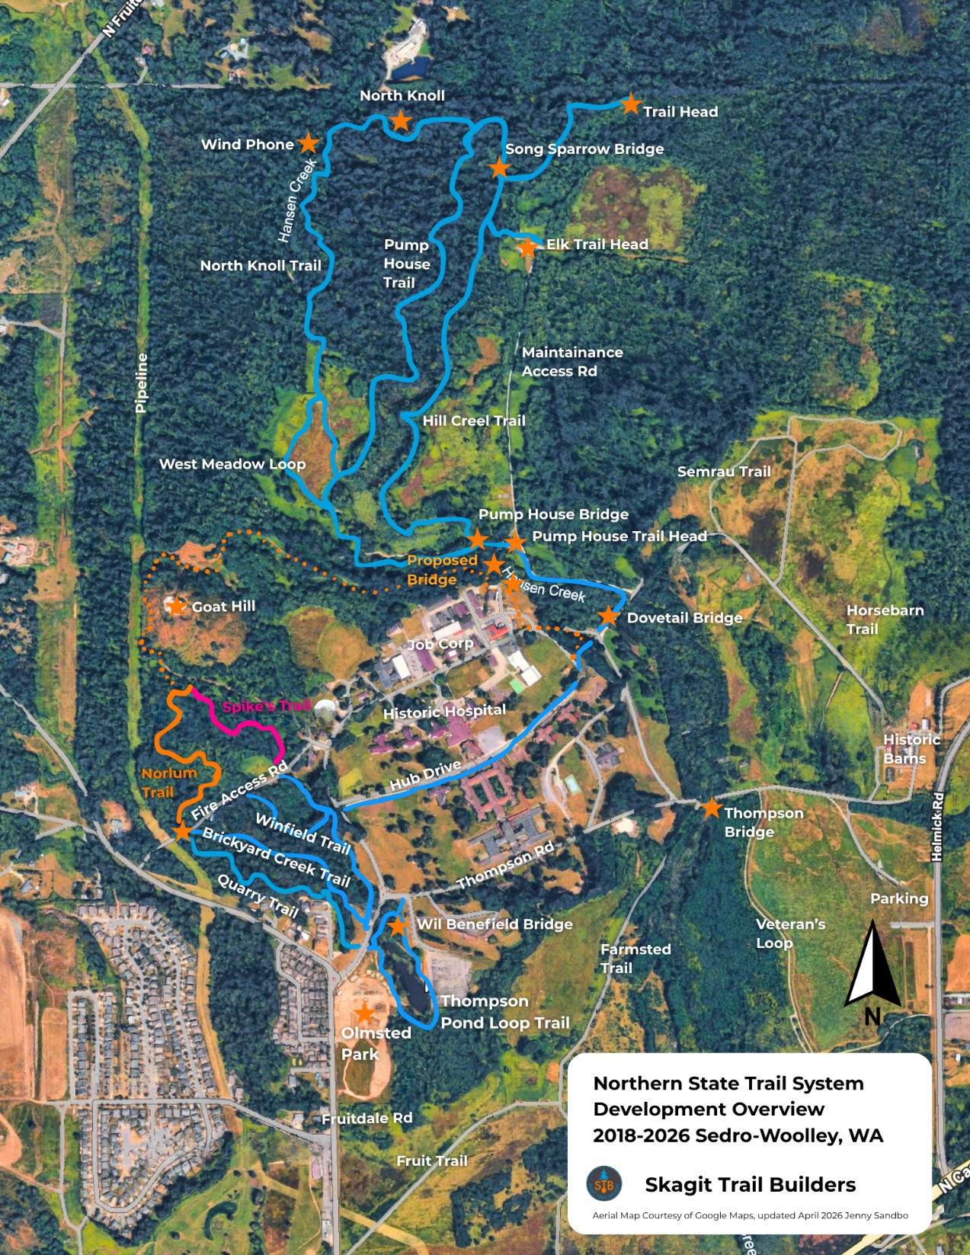
Background
May 9, 2026 was our team’s first work party on Norlum Trail. This trail is our second phase of expanding the Northern State Trail System at SWIFT Center.
Tentative plans are to connect Norlum Trail to Goat Hill, follow the perimeter of Port property along Hansen Creek in the 2027-2028 build year. Phase 3 is funding dependent.
While we wait for finalized plans, we are building Norlum Trail as a loop, connecting back to SWIFT Campus behind Trevennan Hall. The first part of the loop measures about 1700 feet (1/3 mile) and has been built up to drain water and sustain year-round weather conditions. The second part of the loop (called Spike’s Trail) passes through an area identified for future development. This 1250-foot portion will be built as rustic, temporary path.
At our last work party, we completed drain work on the first segment and are ready for pit run capping, the final step in creating a hard-packed sustainable trail surface. On May 23, we will also be performing restoration work, transplanting ferns and applying organic material to naturalize drains and along the trailside. We will also clear the trail tread along the temporary loop through the blackberries.
On May 23 we will be joined by volunteers from the Mountaineers GoHike Course, bringing our volunteer count up to about 40.
Our goals for May 23 include:
- Complete final pit run capping along first segment of trail (materials staging area to fence post marked with pink ribbon, about 1700 feet).
- Naturalize trailside + drains
- Clear and level tread along second segment of the loop (1250 feet Spike’s Trail)

Schedule
8:45 am Volunteer Sign-in at the trail head on the Fire Access Rd.
9 am:
- Introductions, explain today’s work, safety talk, team assignments.
- New volunteers receive their free T-shirt.
- Group Photos

9:30-noon: Trail work
12-12:45: Lunch Break
1-3pm: Trail Work
3pm: Clean-up and organize tools
4pm: Work Party Planning Meeting (by invitation for volunteers who work a full day 9am-3pm)
Teams
Roving Crew Leader: Paul
Restoration: Lynn
Capping: Amelia, Chloe, Craig
Trail Tread: Jerry and Michael
Power Carrier Drivers: Kip, TBD, TBD
Materials staging and loading: JT

Key Dates
● June 13: Norlum Trail. Guest Group Mountaineers GoHike.
● June 27: Norlum Trail. Final work party before summer break.
● July 25: Public History Day at SWIFT
● Aug 22: Music in the Park SWIFT (tentative)
● Sept 12: Music in the Park SWIFT (tentative)

