Skagit Trail Builders
March 14, 2026 Work Party Work Party Plan
Edited March 9, 2026 - Jenny Sandbo, Communications & Project Manager, STB

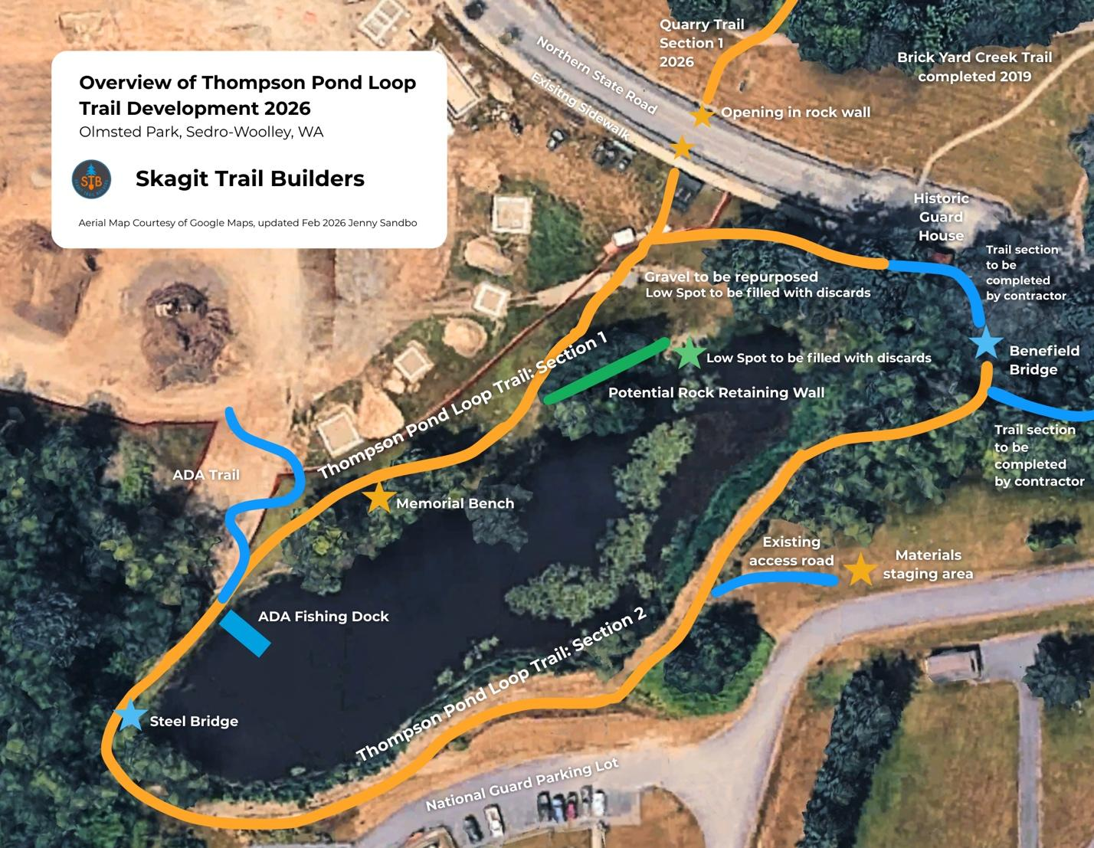
Background
March 14 will be our first work party at Olmsted Park, a public park managed by the City of Sedro-Woolley. The newly developed park is the site of Thompson Pond, designed and built by well-known landscape architects, the Olmsted Brothers, over 100 years ago.
A group of volunteers from Janicki, in partnership with contractor, Art Tuftee, have completed a bridge at the north end of the pond in memory of Will Benefield, a co-worker who recently passed away.
Volunteers from Skagit Trail Builders are routing and building the majority of the loop trail and installing an approximate 100’ long retaining wall on the west side of the pond.
Our goal is to have the trail on the west side of the pond filled with 5/8 minus and ready to use before the City’s ribbon cutting on March 20.
Prior to our March 14 work party, STB Leadership flagged and marked the trail routing and will be doing a test run with the sod-cutter.
Goals
- Remove sod from the sidewalk crossing to the ADA crossing and fill with 5/8 minus. (change: Using ¾ only instead as contractor used most of our ⅝ material)
- Use sod discards to fill identified low spots in the lawn.
- Create a level foundation in preparation for building the rock retaining wall.

Schedule
8:00 am Most of our leadership team meets at the tool shed to bring the tools and power carriers to the trail head. Chloe, Amelia and Jenny meet at the trail head.
8:45 am Volunteers Sign-in at the material staging area on Thompson Rd. Volunteer Parking is located at “the Quad” on Thompson Rd. Directions.
9:00 am:
JT & Paul will lead introductions, make announcements, and explain today’s work.
Jenny will explain the jobs and set-up the work groups.
Safety Talk : Chloe & Amelia
T-shirts & Group Photo
930-noon: trail work
12-12:45 pm: lunch
1-3 pm: trail work
3 pm: clean up and organize tools
4:00 pm: Work Party Planning Meeting (by invitation for volunteers who work a full day 9am-3pm)
---
Teams
Roving Crew Leader and Sod Removal: Paul
Number of volunteers: TBD
Description: Remove sod from trail route. Deliver discards to two areas: rock wall and the low spot in the lawn on the west side of the pond (marked on map). Arrange and level discards to fill in low area in lawn.
Rock Wall Leads: Jerry and Leslie
Number of volunteers: TBD
Description: At the “Fisherman’s Trail” (marked green on the map), use sod discards to build up and level surface, giving special attention to the large trench on the north end of terraced segment.
Capping (5/8 minus) Leads: Chloe/Amelia switch off + TBD
Number of volunteers: 5
Guide the soil delivery: 1
Rake and level: 4
Description: Spread and level 5/8 minus, creating a slight crown or slope for drainage.
Power Carrier Drivers: Kip, Michael and Chloe/Amelia switch off
Description: Carry mineral soil between staging area and the work site.
Material staging and loading: JT
Project Manager/photo/video: Jenny
---
**Additional teams may be determined on Friday afternoon after the conditions and materials are evaluated.
---
Key Dates
- March 14: STB First work party at Thompson Pond. Guest Group SW Earth Club.
- March 20: Ribbon Cutting at Olmsted Park
- March 20-22: WTA Work Party a South Knoll, Quarry Trail
- March 28: STB work party at Thompson Pond. Guest Group Kids ‘n K9s 4H Club.
- April 3: Ground Breaking ceremony at Hilt Creek Falls Park near Rockport
- April 11: STB Work Party at Thompson Pond
- April 25: STB Final work party on Thompson Pond
- March 17: Ribbon Cutting for Yudwasta Big Rock Park (County conference room)
- May 9: STB First work party on Norlum Trail. Guest Groups Skagit Alpine Club and SW Earth Club.
- May 23: Norlum Trail. Guest Group Mountaineers GoHike.
- June 13: Norlum Trail. Guest Group Mountaineers GoHike.
- June 27: Norlum Trail. Final work party before summer break.
- July 25: Public History Day at SWIFT
- Aug 22: Music in the Park SWIFT (tentative)
- Sept 12: Music in the Park SWIFT (tentative)

